Benjy’s Most Excellent New-and_Improved Mat Cutting Guide and Worksheet
Make a mat that has at least 3” around the picture on the top and both sides, and 4” on the bottom. Usually, there’s about ¼” around the picture, but sometimes the mat comes inside the picture 1/4”.
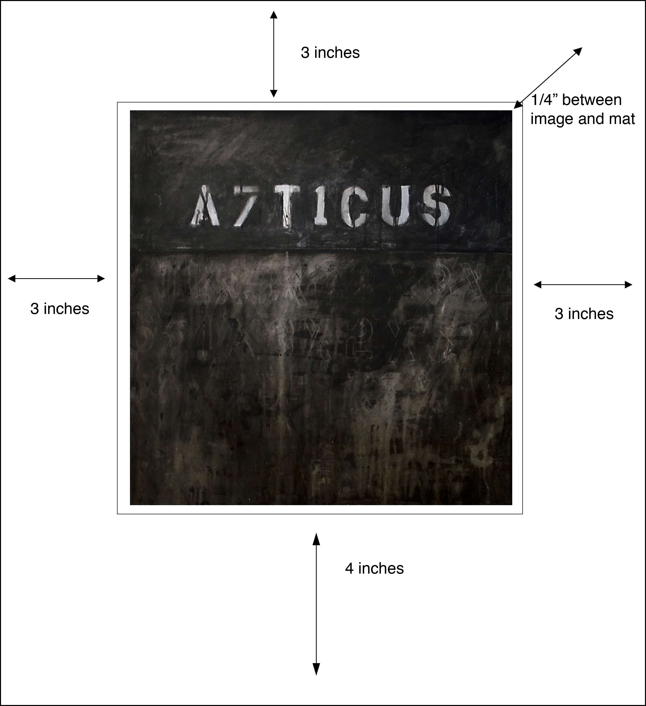

Rules about matting
The job of the mat is to protect and isolate the artwork. If you don’t use a mat, the artwork, if unframed, cannot be easily and safely handled. If framed without a mat, the work is pressed against the glass, which also damages the artwork. Fine art mat is almost always white, off-white or gray. Other colors are not neutral and change the color balance of the image. Don’t pick a green mat to “accent” your art. Put the accent in the art itself, and make the mat neutral.
Cheap mat has a yellowish core that is acidic and ugly. Avoid this mat whenever budget allows, and use museum quality mat instead. Acid causes paper to deteriorate prematurely.
Take your time and use new sharp blades. You cannot cut mats with dull blades. You’ll just get frustrated and ruin a lot of mat. Wash your hands and work only on the clean table. Put your coffee somewhere far away from your artwork. Pay attention.
Worksheet
How wide is your picture? Write that here: PICTURE WIDTH_____________
How tall is your picture? Write that here: PICTURE HEIGHT_____________
Do you want the hole to be a little bigger than your picture or a little smaller? Circle one and cross out the other.
BIGGER:
add ½” to your picture width and write that number here: HOLE WIDTH___________
add ½” to your picture height and write that number here: HOLE HEIGHT___________

SMALLER:
subtract ½” from your picture width and write that number here: HOLE WIDTH___________
subtract ½” from your picture height and write that number here: HOLE HEIGHT___________

Add six inches to your HOLE WIDTH. Put that number here: MAT WIDTH_____________
Add seven inches to your HOLE HEIGHT. Put that number here: MAT HEIGHT___________
Do all your numbers again. If they are not the same, you’ve screwed it up. Do it again. Once you get it right, you’re ready to start cutting.
- Cut two pieces of mat, using the straight edge cutter. Make sure they are the right size.
- Set the mat cutter to 3” border, and use a pencil to draw the sides and top around the mat.
- Reset the mat cutter to a 4” border and use a pencil to draw the bottom.
- Measure the box you’ve drawn. If it’s not the same as your HOLE WIDTH AND HEIGHT, you’ve screwed it up. Do it again.
- When you have it right, cut the mat with the bevel edge cutter.
- Check the hole by placing the mat on the picture and looking at it. If it’s not right, start over.
- Hinge the mats together on the top, using masking tape or packing tape.
- Tape the two mat boards together with masking tape. Set your tees of archival tape in the right place. Only moisten the glue side that goes down.
- Close the mat and position the art under the top mat.
- Lift the mat and hold down the bottom of the art. Then lift the top of the art and moisten the part that goes up. Press the art firmly into the tape.
- Clean up your fingerprints, if any.
- You’re done!!

